Manufacturing Procedure (Manual)

# Antenna Hinge

1. Cut material into 20mm segment(s).
2. Face PC rod accordingly so the result is a 7.8mm square block.
3. While doing step 2, make sure that height is 6mm.
4. Rotate part and drill centre hole (1/8”), use centre drill (M1 and/or M2).
5. Rotate part and use 1/16” end mill to mill out slot for spring arm.
6. Rotate part and use 1/16” end mill to mill out slot for spring body.
7. Rotate part and drill antenna hole (1/8”), use centre drill (M1 and/or M2).
8. Chamfer to approximate dimensions, ~0.7mm.
9. Debur to perfection.

# Mounting Hinge

1. Cut material into 28mm segment(s).
2. Face Al rod accordingly so the result is a 12mm square block.
3. While doing step 2, make sure that height is 6.3mm.
4. Rotate part and drill centre hole (1/8”), use centre drill (M1 and/or M2).
5. Rotate part and use 1/16” end mill to mill out slot for spring arm.
6. Use 1/16” end mill to mill out slot for spring body.
7. If feeling up to the task, rotate part and mill the angled stopper. If not, mill out the stopper at a right angle at the interior of the stopper on the technical drawing.
8. Rotate part and drill mounting holes (M3), use centre drill (M1 and/or M2).
9. Mill out excess material around mounting holes, use centre drill (M1 and/or M2).
10. Use counter sink tool to make the appropriate counter sinks around mounting hole.
11. Debur to perfection.

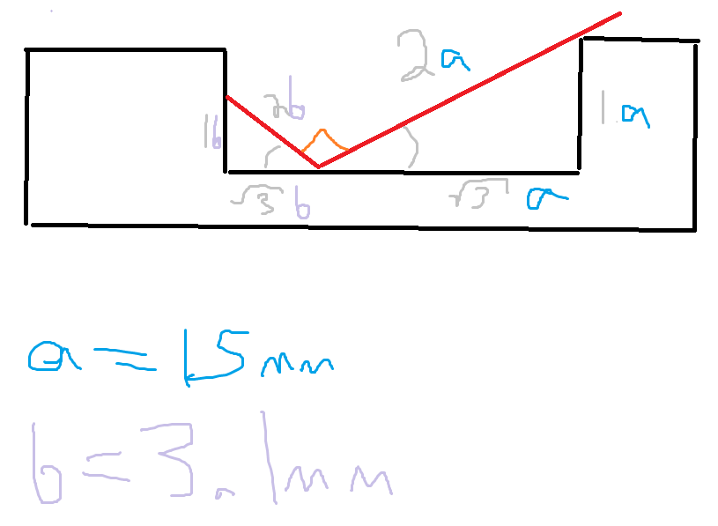

***Stopper Cradle***